Access Notes: Modern Fuel Artist-Run Centre
Last Edited: June 28, 2024
Created by Erin Ball
Template by Erin Ball and Maxime Beauregard

Address: 370 King St W #305, Kingston, ON K7L 2X4, located on the third (top) floor inside the Tett Centre for Creativity and Learning

Email : info@modernfuel.org

Phone: 613-548-4883

Hours: Tuesday through Saturday 12-5pm and Thursday 12-8pm. Special events may occur outside of these hours.

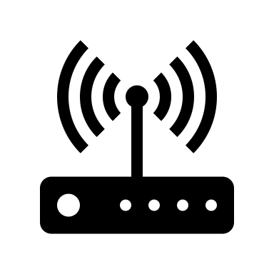WIFI: Free Wi-Fi is available upon request.

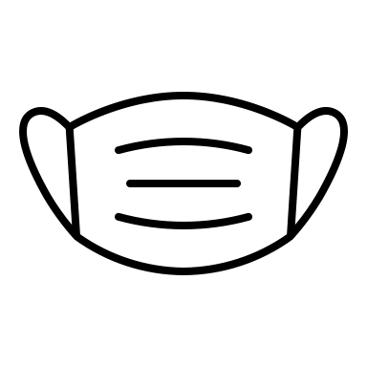Mask Policies: Masks available upon request. The policy is to do whatever makes you the most comfortable. Sanitizer is available on the table on the inside right side of the space.

Childcare Policies: Children are very welcome in the space. Parents and caregivers are encouraged to accompany. Please note that art is not censored and there may be mature themes.

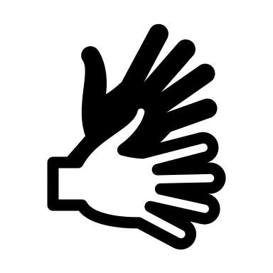Languages: Staff speak English.

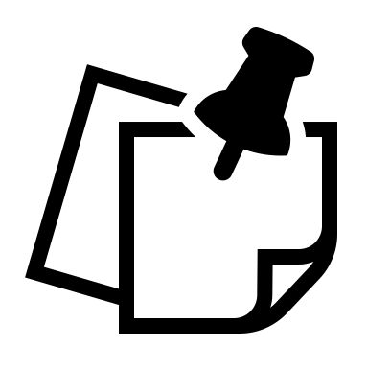Other Notes: There is filtered water available and cups. There is a first aid kit in the space. There is a naloxone kit on the third floor accessible via Tett Centre staff.

Summary of Access Notes (Short Version)

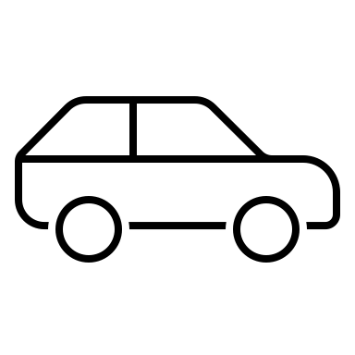Transportation and Parking: There are four accessible parking spots and many spots that are not designated as accessible. There is a bus stop across from the Tett Centre.
More information, photos, and image descriptions are below in the detailed access notes.

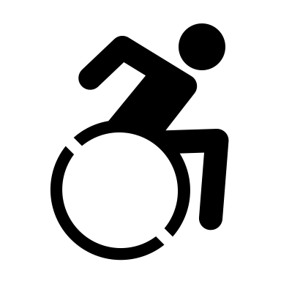Wheelchair Access: The Modern Fuel space is accessible for most wheelchair users. The door remains open during operating hours. There are no mats or barriers in the space. The gallery does change but there is always a sufficient barrier-free path. There is wheelchair access throughout the Tett Centre building. More information, photos, and image descriptions are below in the detailed access notes.

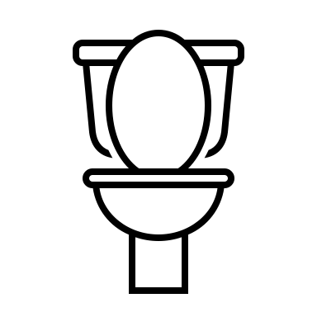Washrooms: There are washrooms on each floor of the Tett Centre. There are three sets near Modern Fuel. Coming out the door of Modern Fuel, to the left, there is a short hallway with first the gender neutral, single stall washroom on the left. This washroom also features grab bars, a large bench that can be used as an adult size change table, space under the sink, and two cords for emergencies. There are no automatic buttons for the doors.

Further into the hallway, there are gendered washrooms with multiple stalls. To the left are the men’s and straight to the back are the women’s. More information, photos, and image descriptions are below in the detailed access notes.

Sensory Notes: There is a lower sensory room inside Modern Fuel. To access it, let staff know that you would like to use it. There is sometimes low volume music playing in the space and sometimes the installations include sound. The lighting inside the main space is dim ceiling track lighting. For programs, sometimes the fluorescent lights will be on. During the day, the sound inside Modern Fuel is minimal. In the evenings there are dance classes next door and it can get loud.

Contrast/Textures: There is some visual contrast in the space. The floors and wall are different colours and there are borders on the doorways. The floor is concrete. The installations in the galley change.

Scent Policy: We encourage the use of unscented products though we cannot guarantee that we are 100% scent free.

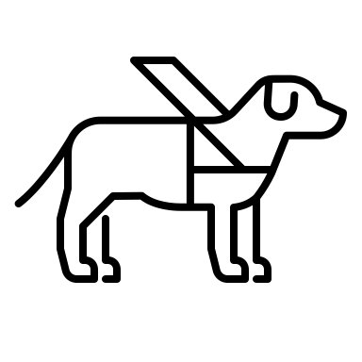Service Animal Policy: We welcome service animals and have water bowls. It is common to encounter animals in the space.

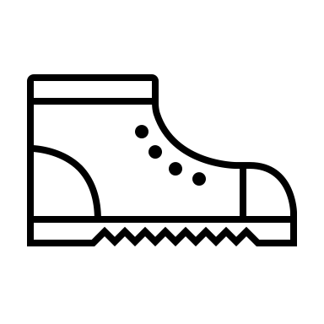 Shoe Policy: There is no shoe policy. People typically keep their shoes on though people are welcome to do whatever is comfortable.

Additional Notes: In addition to water, there is a mini fridge, microwave, coffee pot, and printer available for use. Drop ins are welcome. For any access needs that are not mentioned in these notes, please connect with us via phone or email.

Questions/Feedback: We welcome accessibility questions and feedback. You can reach us by phone at 613-548-4883 or by email at info@modernfuel.org.

Detailed Access Notes with Photos and Descriptions

Table of Contents
Parking
Public Transportation
Entrance of Tett Centre (two entrances)
Directions Upon Entering
Entrance to Modern Fuel
Main Gallery Space
Office Space
Staff
State of Flux Gallery Space
Tech Rental Space/Lower Sensory Space
Window Gallery Space
Bathrooms
Exits and Fire Exits

Parking

There are two parking lots at the Tett Centre. The first is on the right after you turn into the Tett Centre complex. There are four free accessible parking spots for visitor use. The numbered spots are for tenants.

The second parking lot is past the Isabel Bader Centre. There are many spots, both accessible and not. This is paid parking. Note: it is down a hill.
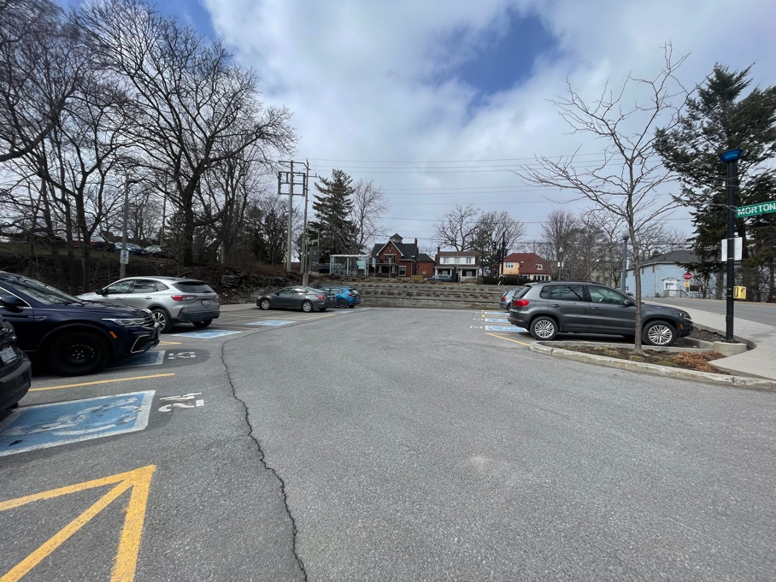
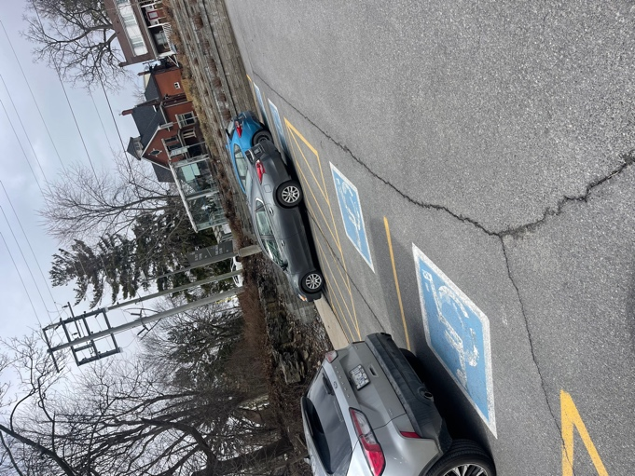

Images: Two photos of the parking lot in front of the main door to the Tett Centre with four accessible parking spots and several numbered parking spots for tenants.

Path To Second Parking Lot

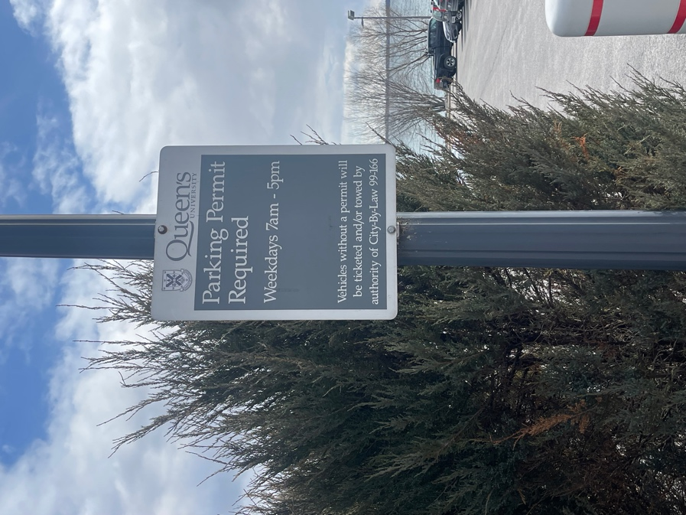
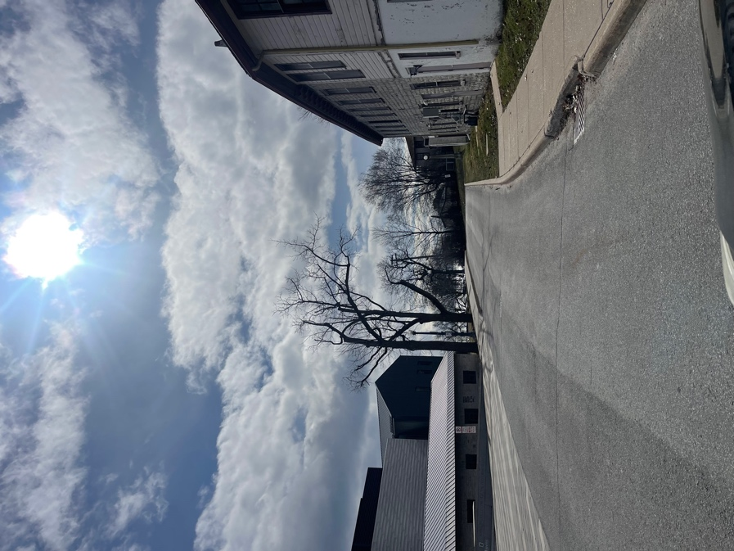

Images: 1. A photo of the road that continues past the main door to the Tett Centre and past the Isabel Bader Centre to the second parking lot. 2. A photo of the sign in the parking lot that says Parking Permit Required weekdays 7am – 5pm.
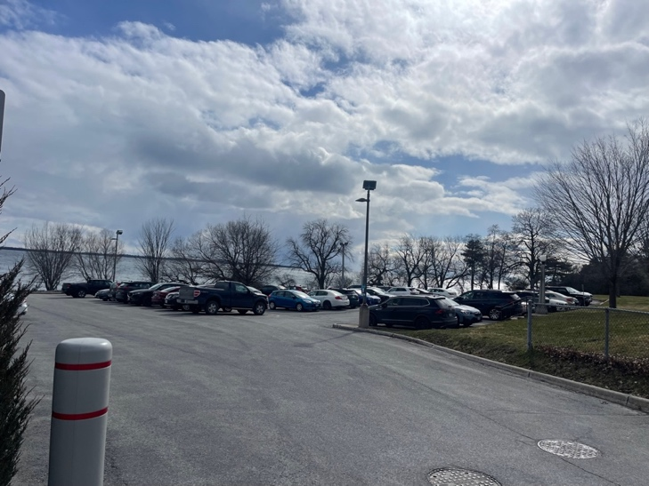

The second parking lot with both accessible parking spots and spots that are not designated.

Image: A photo of the parking lot with Lake Ontario behind it.

Public Transportation:

There is a bus stop just outside of the Tett Centre/Isabel Bader Centre complex. The buses are routes 3, 501, and 502. To plan your route, visit cityofkingston.ca/residents/transit/bus-schedules
From the bus stop, turn right into the complex and the Tett Centre is the first building on the left.

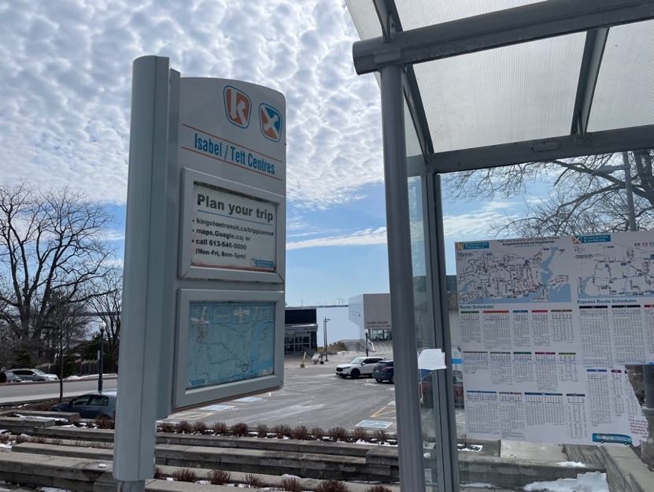

Image: The bus stop on King Street, directly in front of the Tett Centre.

Entrance of Tett Centre

There are two entrances to the Tett Centre.

- Main Entrance
This entrance is most easily accessed from the bus stop, the accessible parking lot, and King Street. The doors are automated and slide open with 179cm or 69 inches of clearance (width). There are no barriers at this entrance.

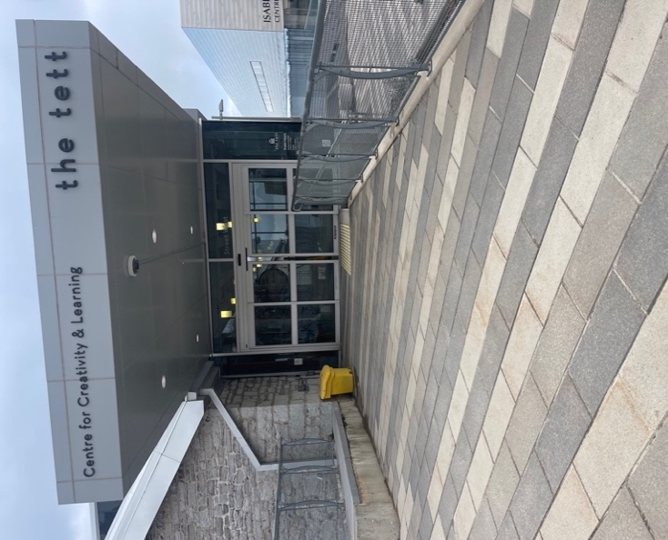

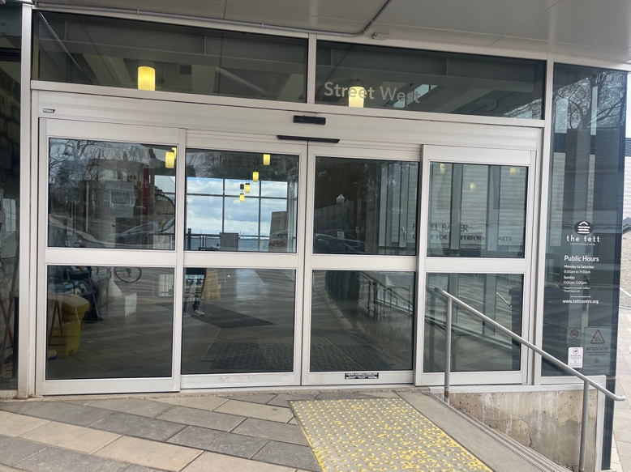

Images: Two photos of the main entrance to the Tett Centre. The doors slide open and closed and are automated. Outside, to the right of the doors is a staircase with a railing that goes towards the Isabel Bader Centre.

- Lakeside Entrance
This entrance is most easily accessed from the second parking lot. There is a path along the water of interlocking bricks that goes to the entrance. There are automated buttons on the doors. There is a planter at this entrance however there is 127cm or 50 inches of clearance. There are no other barriers. The door width is 95cm or 30 inches and it opens out. There are turn handles. This entrance tends to be busier as Juniper Cafe is located inside to the right and there is a patio outside at this entrance for the cafe. There is a defibrillator inside the lakeside entrance on the left wall.
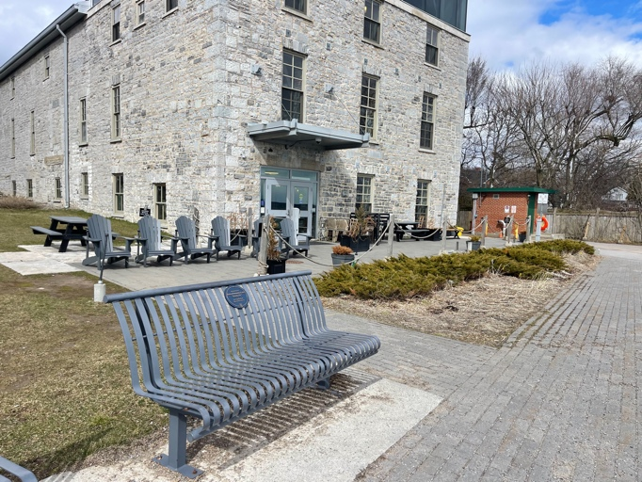
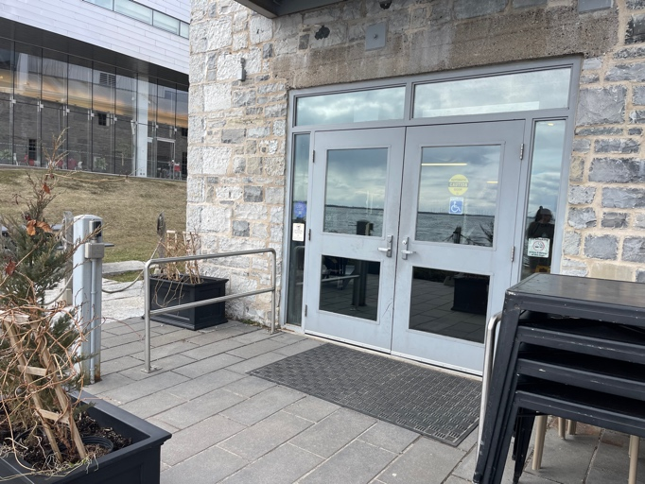

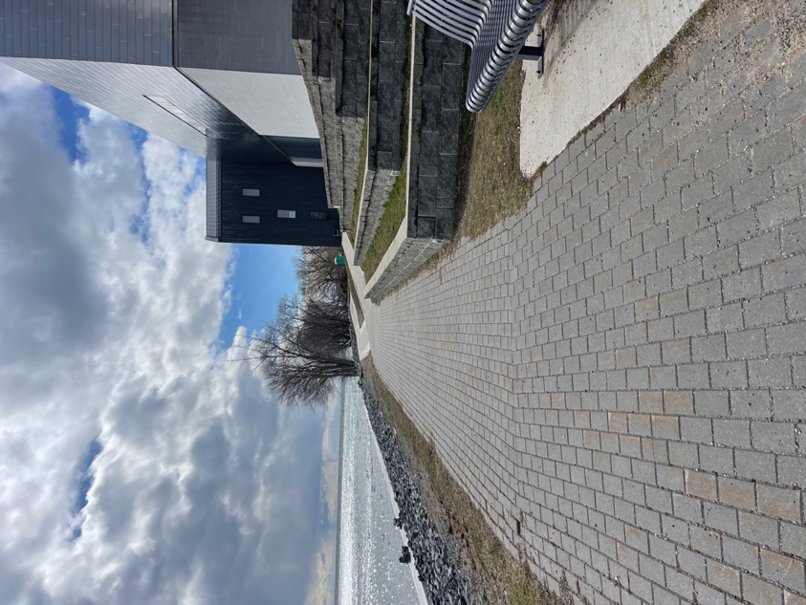
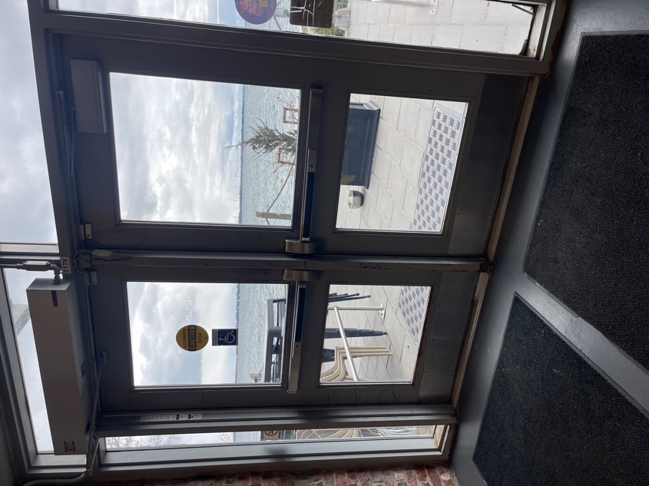

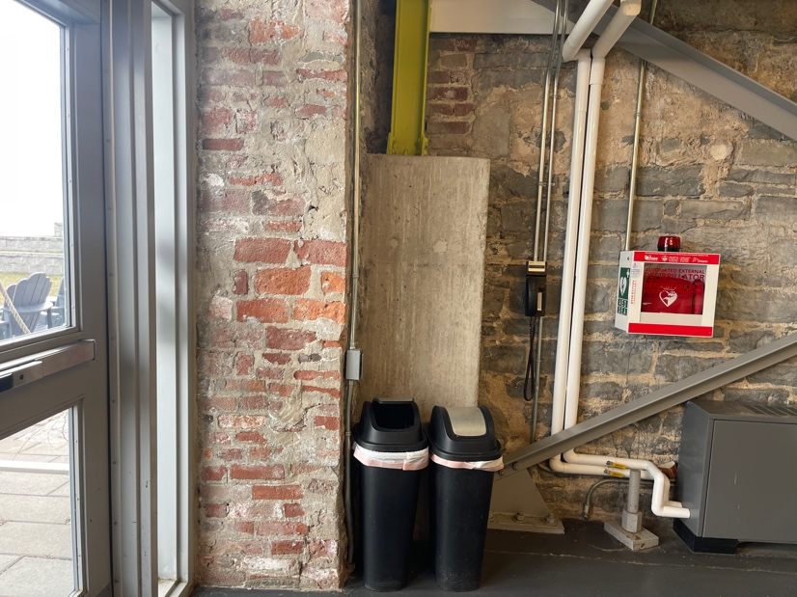
Images: 1. The interlocking brick path from the parking lot to the Lakeside entrance. 2. The Lakeside entrance doors. There is an automated button on the left if you are facing the doors and there is a planter with clearance for most people and mobility devices. The doors open out. 3. The Tett Centre from the Lakeside entrance. There is a bench along the path before the Tett Centre and just outside of the building there are chairs and the Juniper Cafe patio. 4. The Lakeside entrance doors from the inside. The automated button is to the right if you are facing the doors or there are push handles. 5. To the right of the Lakeside entrance doors inside the building there is garbage and recycling, and a defibrillator.

Directions Upon Entering:

From the main entrance:
After entering the doors, go straight past the stairs and then turn left. There is an automatic button to open the door on your right. Once you have gone through the door, turn right. Modern Fuel is through both the third and fourth doors on the left.

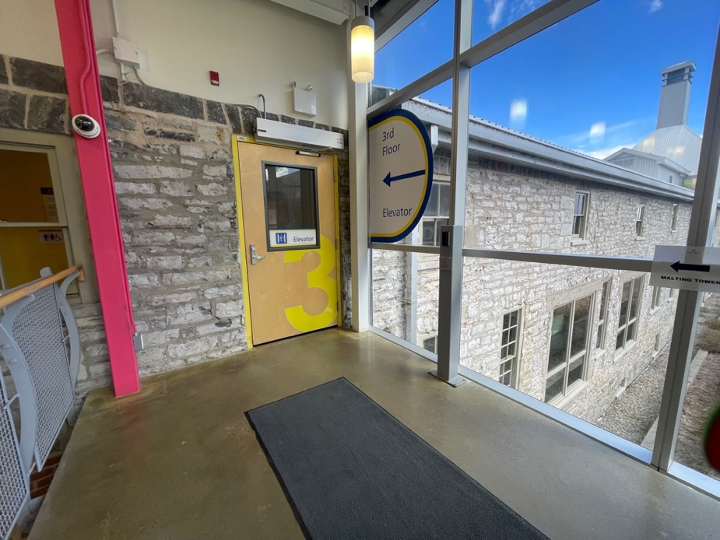

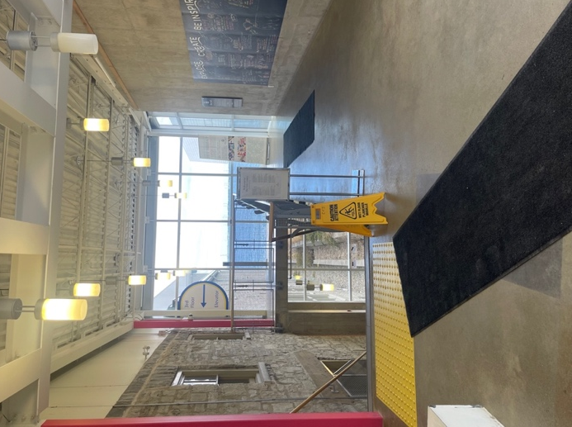

Images: Two photos inside the main doors. On the left side is the stairway with a railing on both sides to go down to the first and second floors. On the right side is the door to enter to go to Modern Fuel (to the right of the stairs and turn left).

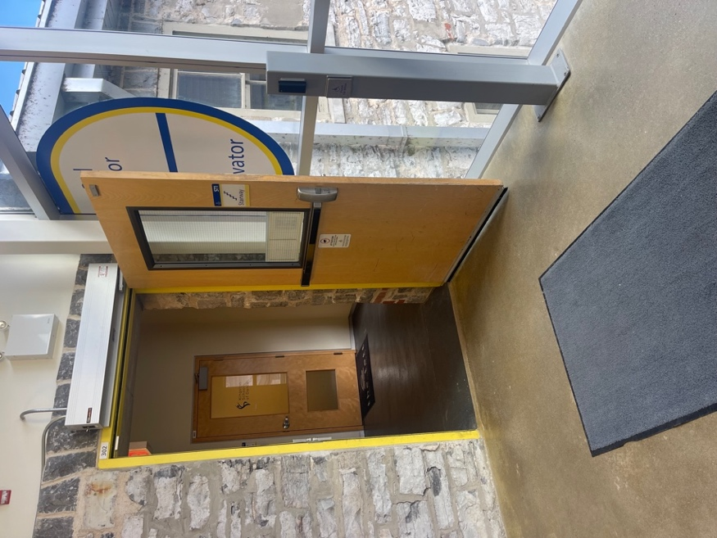
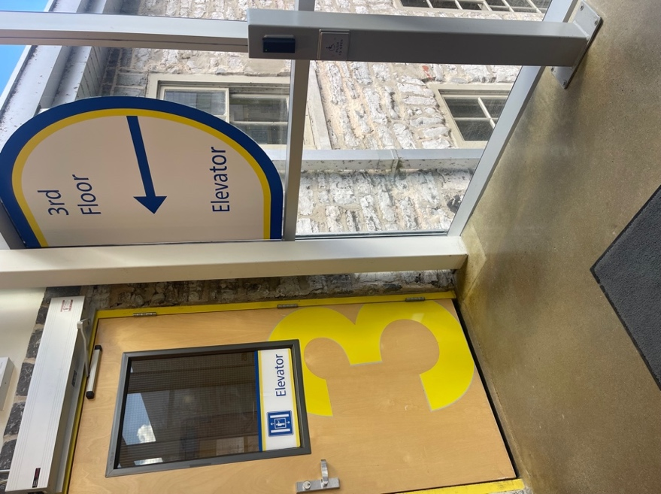
Images: 1. The door to the elevator with the automatic button on the right.
2. The open door to the elevator and hallway where Modern Fuel is located.

From the lakeside entrance:
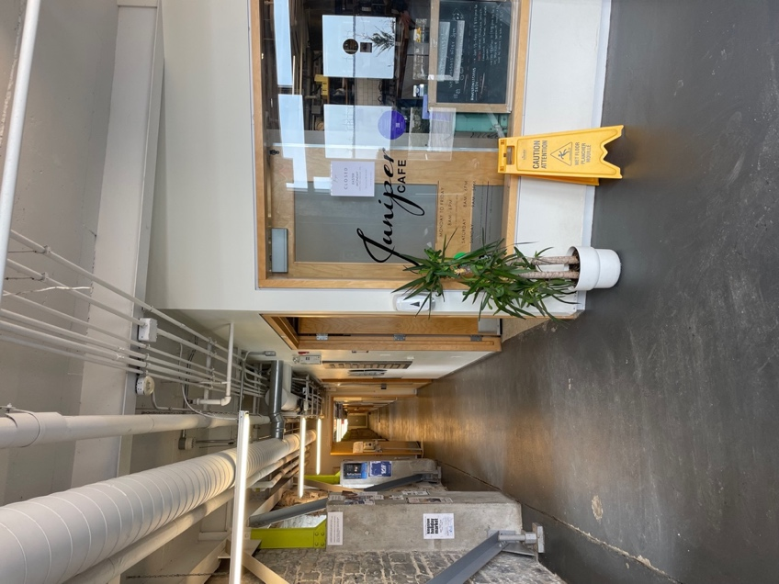
Modern Fuel is on the third or top floor and Juniper Cafe is on the first or bottom floor. Once you have entered the building, follow the hallway all the way to the end and the elevator is on the right side. Take the elevator to the third floor and turn left. Modern Fuel is both the third and fourth doors on the left.

Image: Inside the Lakeside entrance to the right is Juniper Cafe. The hallway straight ahead leads to the elevator on the right at the end of the hall.

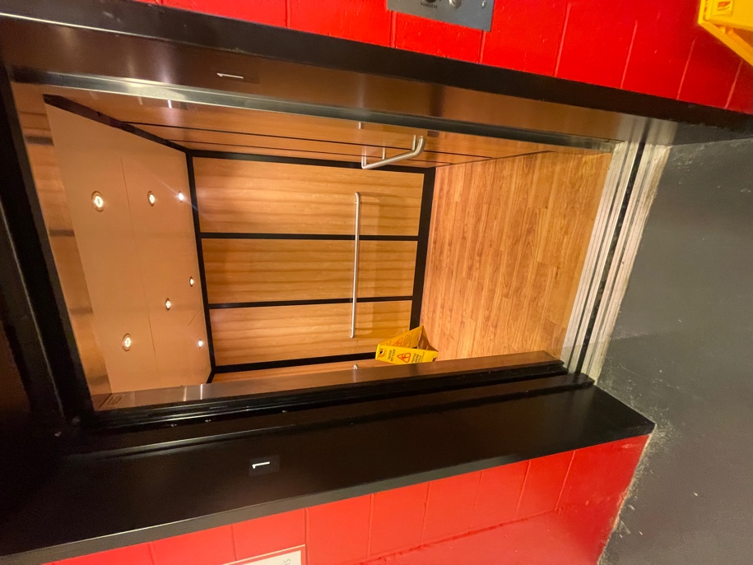
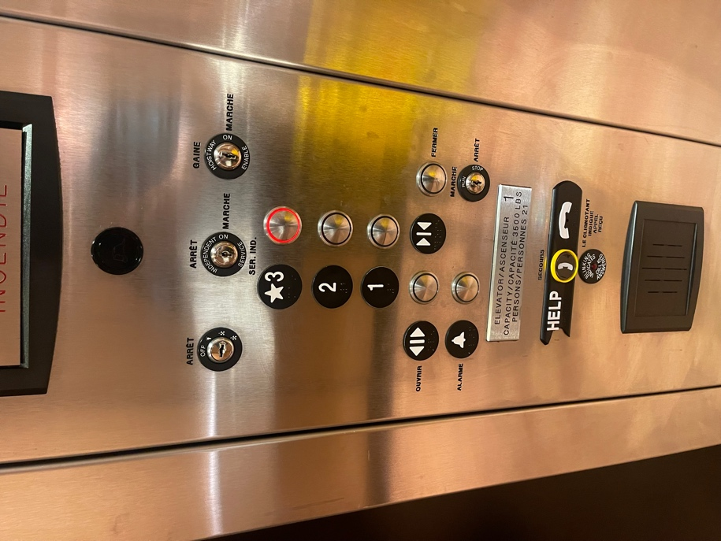

Images: 1. The inside of the elevator with railings on all sides. 2. The buttons in the elevator. Options for the first, second, and third floors. Modern Fuel is on the third floor.

Entrance to Modern Fuel

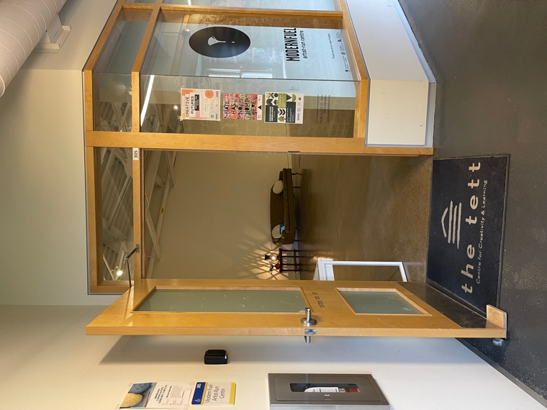
The first door to Modern Fuel has a turn handle and it opens out. It is 91.44 cm or 36 inches wide. There are no automatic buttons for the door, but it is typically propped open.

Image: The first door to Modern Fuel. There is a mat on the floor outside of the door and on the right side of the door is part of the window gallery.

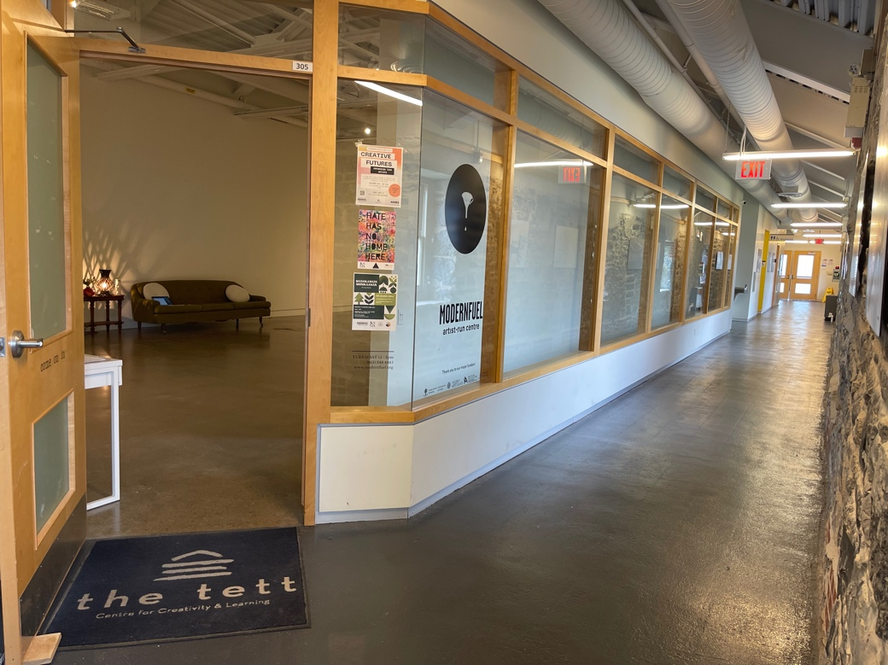
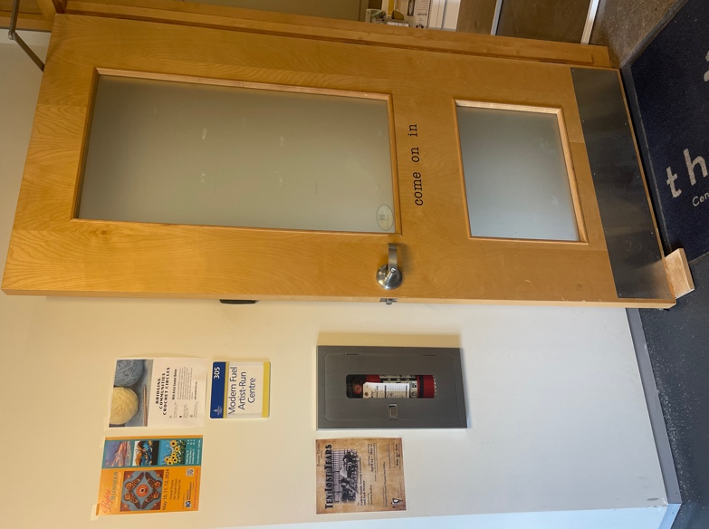

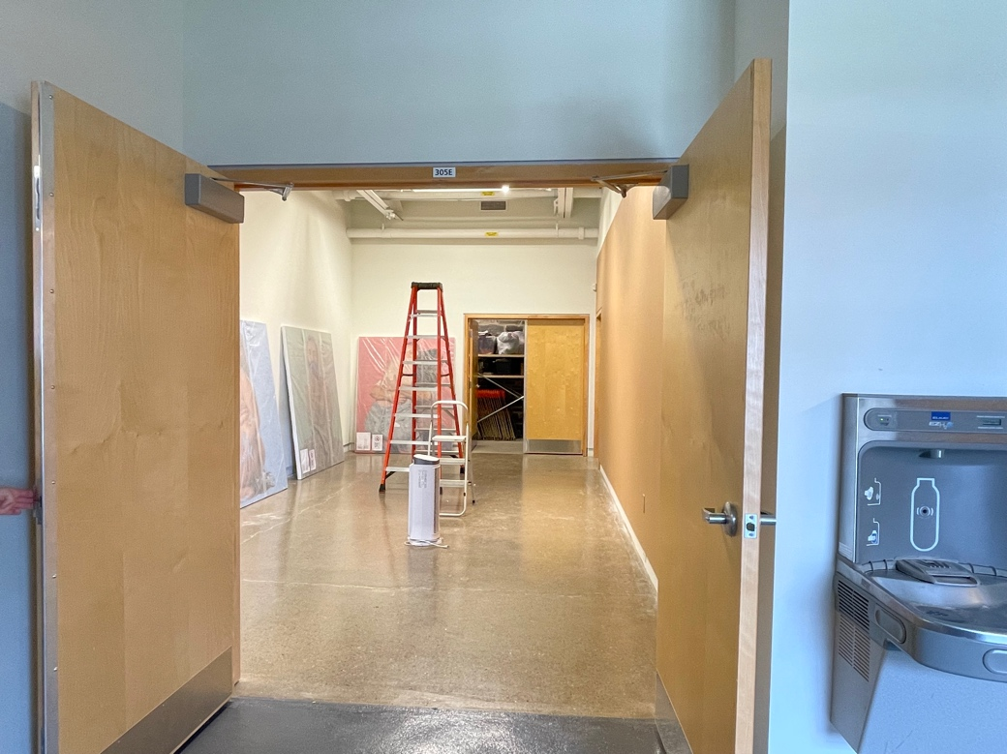

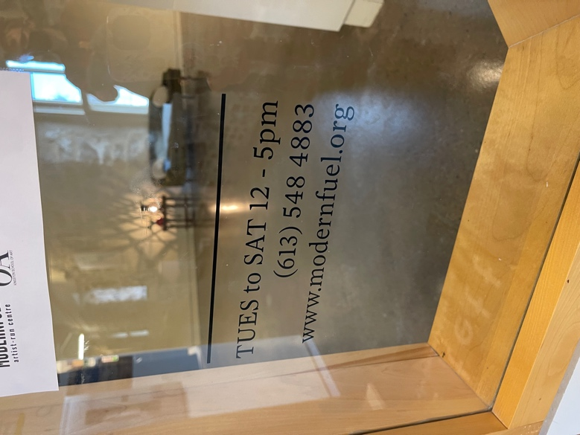

Images: 1. The wall to the left of the door to Modern Fuel. There is a sign that says Modern Fuel Artist Run Centre in English and Braille. There is also a fire extinguisher and some posters. 2. Another vantage point of the door
that includes the hallway that continues to the second doors to the centre, and the bathrooms. 3. On the window to the right of the first Modern Fuel door, the hours and contact info are posted: Tues to Sat 12-5pm. (613) 548-4883. www.modernfuel.org 4. The double door entrance that is the fourth door in the Tett Centre hallway. On the right side of the doors just before entering is the water fountain. A container for water is needed for the fountain.
Main Space Inside Modern Fuel

There are no barriers upon entering the gallery space. Inside the door on the left wall is an access table with various items in drawers (and a sign indicating they are there) like sunglasses, stim items, menstrual products, food, and more. There are also post cards, hand sanitizer, a donation box, and pens on the table.

The sound inside the space is minimal during the day. At night there are dance classes next door, and it can get loud.

The installations are always changing and there is always a barrier-free zone. The lighting is dim track ceiling lighting. The floor is concrete and is beige. The walls are white.

The fire alarm is both auditory and visual. The nearest pull system for the fire alarm is across from the elevator in the hallway. The only ways out are through either door in the hallway to the Tett Centre (in case of emergency). The Tett Centre building is largely made of limestone.

If there are no staff members in the main gallery space, they are likely in the office.

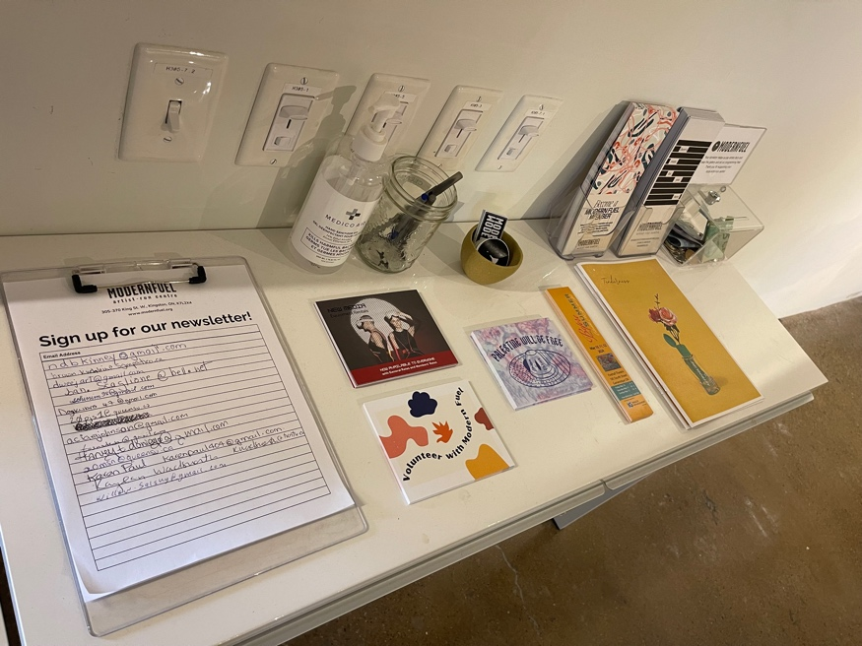

Image: The table on the left wall inside Modern Fuel. On the table is a sign-up form for the newsletter, postcards, hand sanitizer, and a donation box.
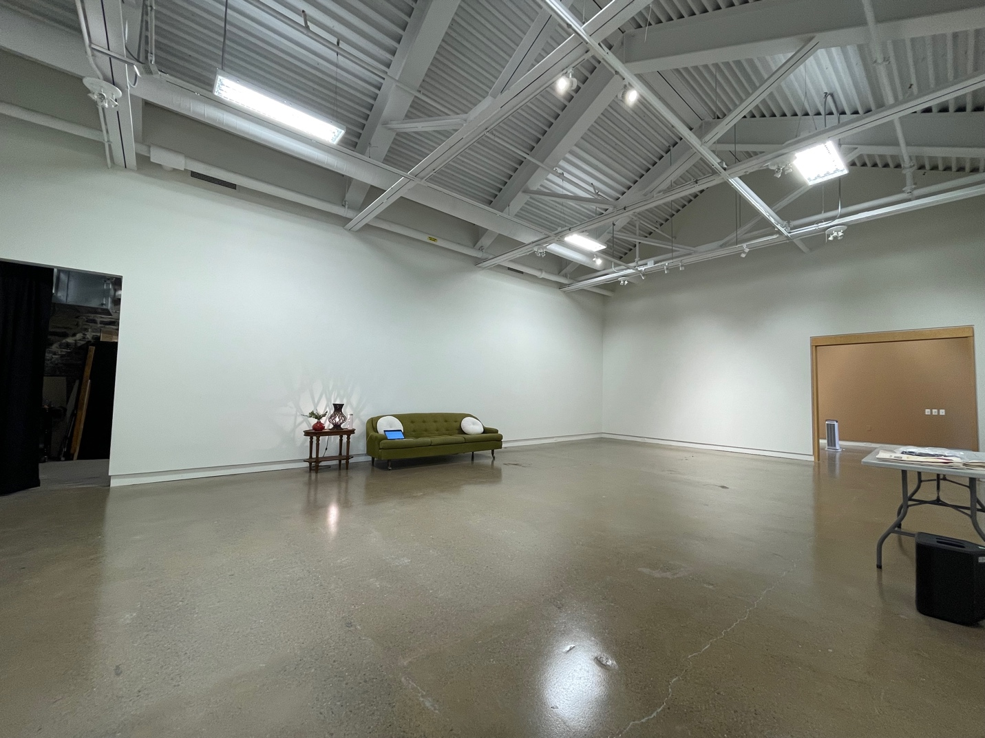

Image: Inside the main space in Modern Fuel. In this photo there is no installation. At the back of the space is a couch and table. On the left side is the door leading to the office. On the right side are a set of double doors that lead to a smaller gallery and the lower sensory space.

Modern Fuel Office Space

The entrance to the office (which is on the back left side of the gallery) measures 37.5 inches. The lighting in the office is a combination of natural lighting and fluorescent lights.

In the office there is a resource library for public use by loan.

There is a kitchenette at the far-right side of the office. There is tea and water available. Do not drink the water from the sink. There is a water fountain just outside of Modern Fuel (to the left as you exit, it is on the wall). The narrowest point leading to the kitchenette is 69.85 cm or 27.5 inches.

Image: The office and back space inside Modern Fuel. The vantage point is from the entrance to the office through a door on the left side inside the main area of Modern Fuel. The photo is taken facing the right. On the left side of the office is a brick wall with windows, lamps, and tables along it. At the back is the kitchen area. On the right side of the office are desks and chairs.

Modern Fuel Staff
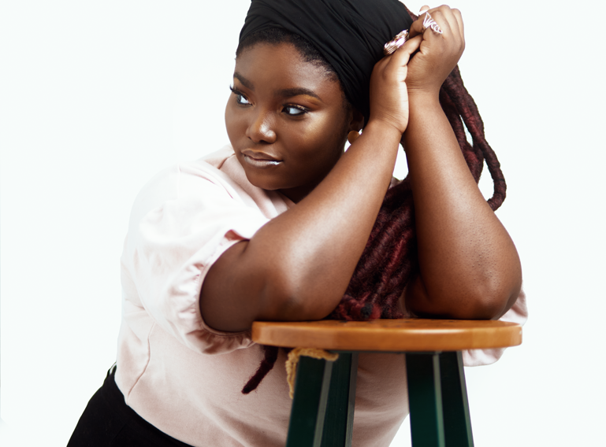

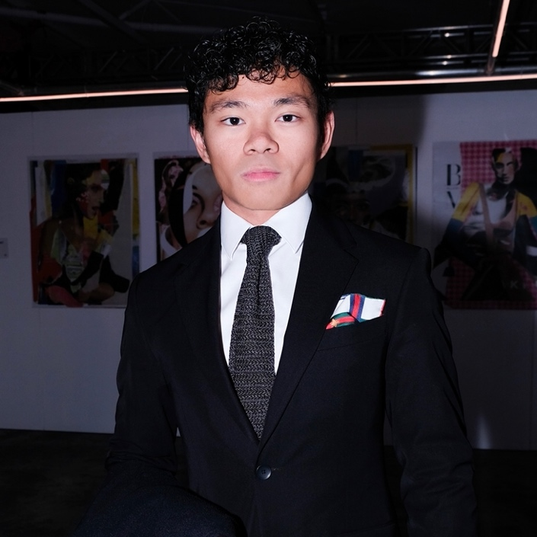
Images: 1. Maddi Andrews, a white settler smiles in front of a colourful background with words and images like a rainbow and love. Maddi is the Executive Director at Modern Fuel. 2. Oyíndà Áláká, a black woman, poses with her arms on a stool, hands clasped. Her long locks cascade from one side of her head to the stool. 3. Marcus Baron Young, a man of Asian heritage and European cultural upbringing, wearing a black suit, tie, and white shirt, poses austerely in front of a dimly lit space with artwork such as fashion images. Marcus is the Gallery Administrator at Modern Fuel.

State of Flux Gallery Space

The State of Flux Gallery Space can be accessed by going through the double doors to the right inside the main gallery or by entering the double doors in the hallway of the Tett Centre. From the hallway, it is the fourth door on the right.

The State of Flux Gallery is similar to the main gallery but smaller.

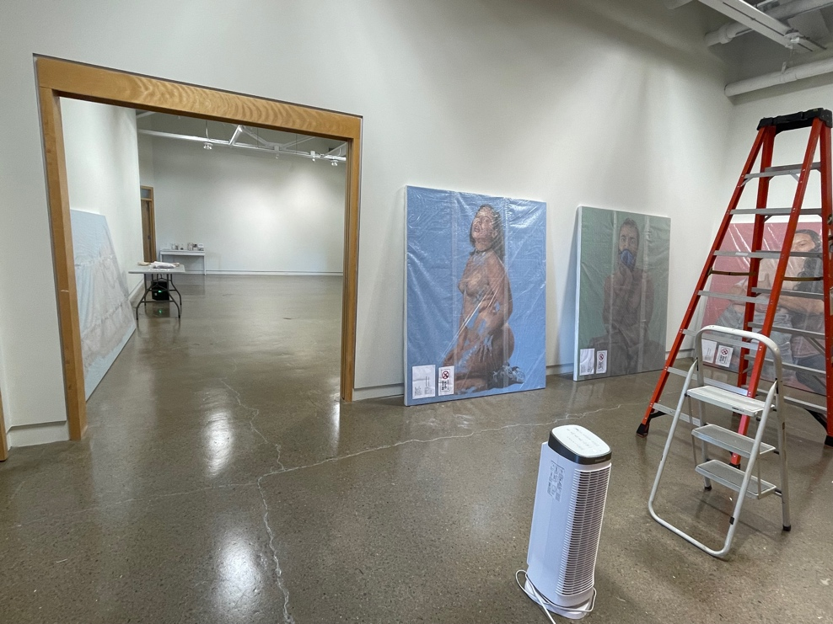
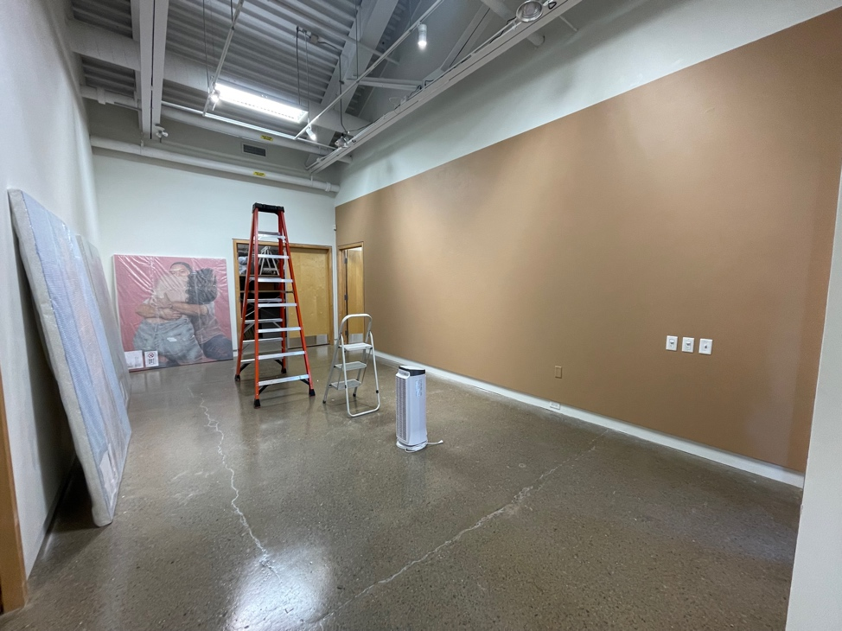

Images: 1. Inside the State of Flux gallery. There are ladders and paintings in preparation for an installation. The double doors to the Main Gallery are open and barrier free. 2. Inside the State of Flux gallery vantage point from the double doors that connect to the Main Gallery. The door on the back right side is the door to the tech rental and lower sensory space.

New Media Workshop/Lower Sensory Space

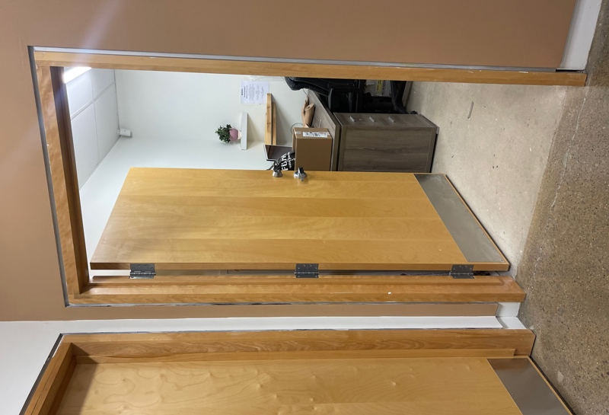
The lower sensory space doubles as a space for tech rentals so the door is kept locked. The door opens in with a turning lever handle. It measures 96.52 cm or 38 inches. Please connect with Modern Fuel staff to access it. When used for a lower sensory space, there will be alternate lighting to the fluorescent lights. Stim items, blankets, pillows, and ear plugs are available.

Image: The door that opens inward to the New Media Workshop/Lower Sensory Space.
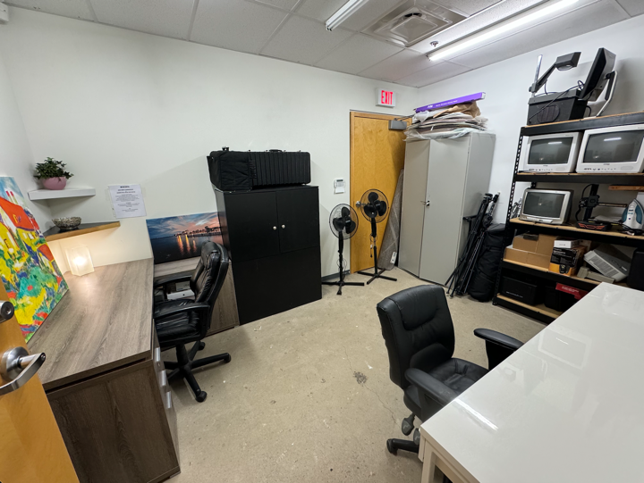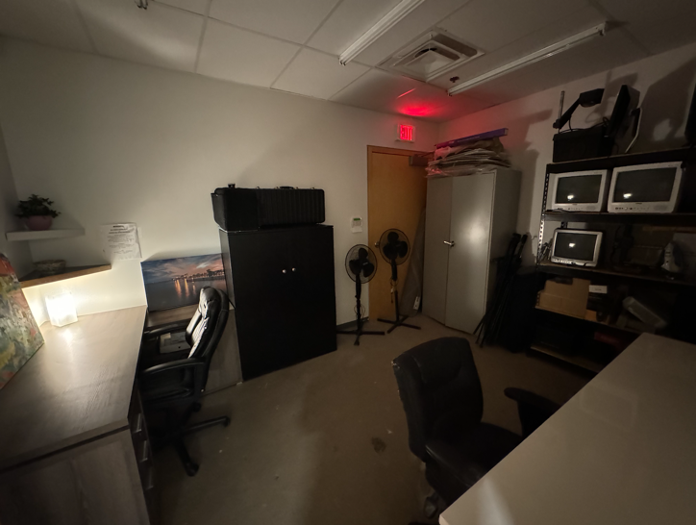

Image: Two photos of The New Media Workshop. There are desks, chairs, and tech equipment with fluorescent lighting in the first photo. In the second, there are dimmer lights.

Window Gallery Space
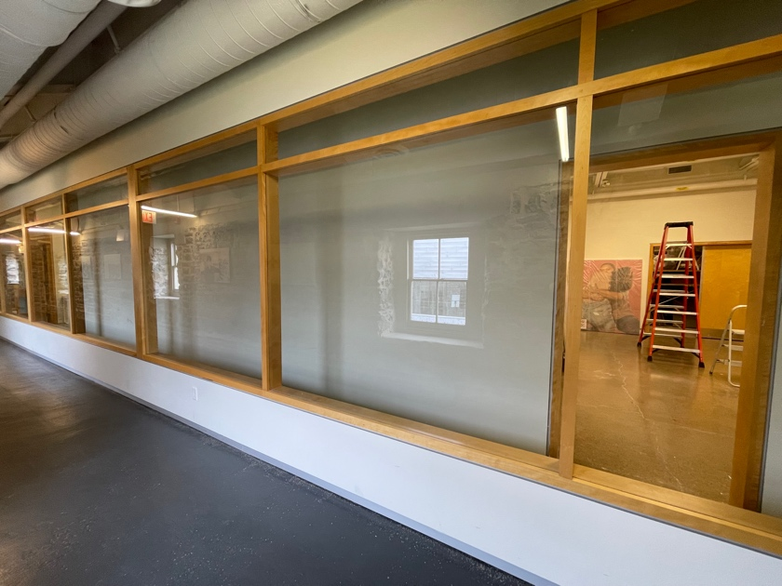
The Window Gallery Space is experienced from the Tett Centre hallway and spans most of the length of the Modern Fuel space.

Typically only exhibiting artists will need to access the inside of the Window Gallery. The entrance is 89.53cm or 35 ¼ inches wide and inside the Window Gallery is 78.74cm or 31 inches.

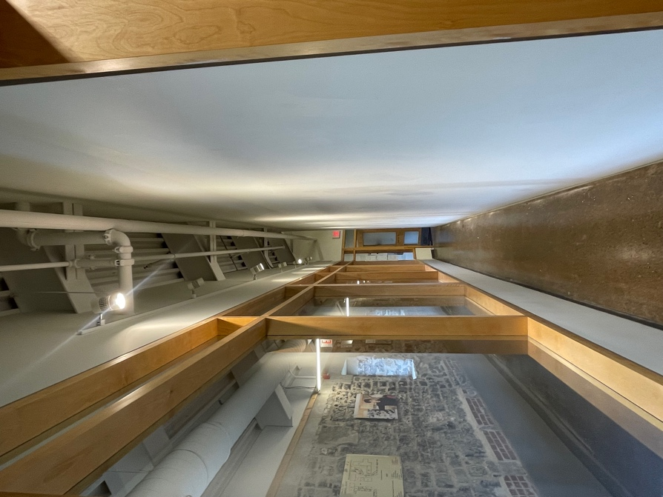

Images: 1. The Window Gallery that spans the Tett Centre hallway portion of Modern Fuel. There are glass windows with wooden borders, and it is empty in the photo. 2. The window gallery from the inside perspective: a narrow long gallery area.

Bathrooms
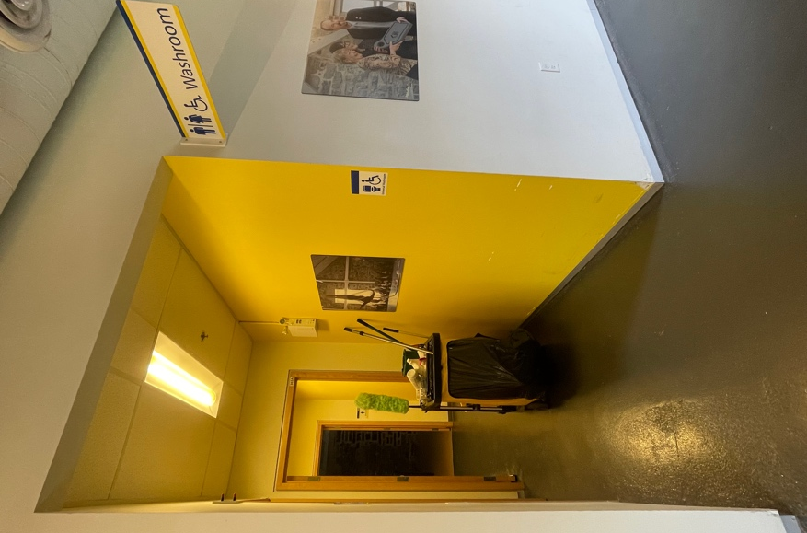
There are three different bathroom options on the third floor. From either Modern Fuel door, turn left and then left. There are no menstrual products in the washrooms however tampons are available in the Tett Centre office.

Image: The hallway leading to the three
bathrooms.

Gender Neutral, “Universal” Washroom: Exiting Modern Fuel, turn left and then left. This is a single stall washroom with horizontal and vertical grab bars beside the toilet and a horizontal bar behind. There is a large bench that can be used as an adult size change table, space under the sink, and two cords for emergencies, one is located to the left of the toilet if you are on it and the other is on the left wall beside the bench if you are on it. The toilet is an automated flush system, but the censor is blocked by the toilet seat lid. Close the lid and wait for the sensor to activate or use the silver button beside the censor to manually activate the flush.

The door is 98cm or 38.5 inches wide. There are no automatic buttons. The door opens in and there is a turning lever handle. The door does not swing backwards when opened. There is a push lock on the interior door handle, which unlocks when you turn the handle to exit.

There is space under the sink and the mirror is long and starts just above the sink. The soap is a liquid manual dispenser and is within reach of someone who is sitting (depending on the situation).

There is a fluorescent light above the mirror and one on the ceiling. The manual paper towel dispenser is also within reach of someone who is sitting (depending on the situation).
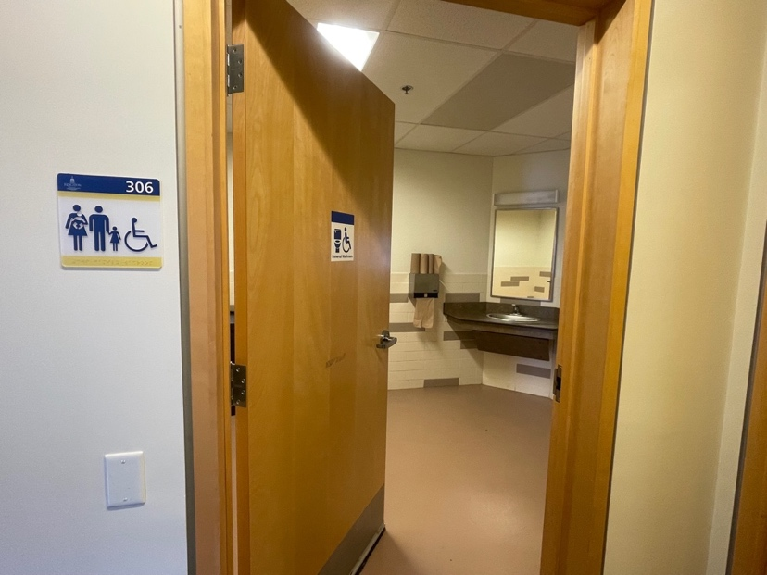
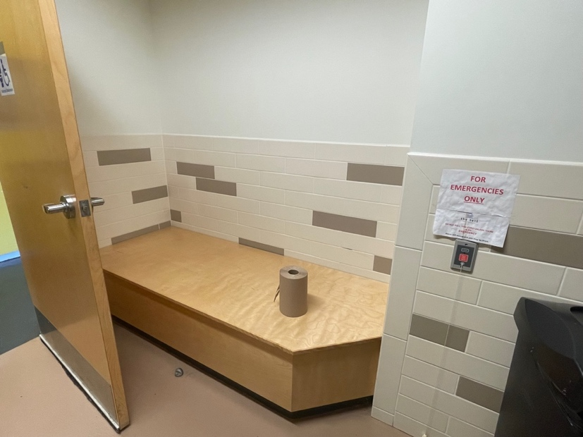

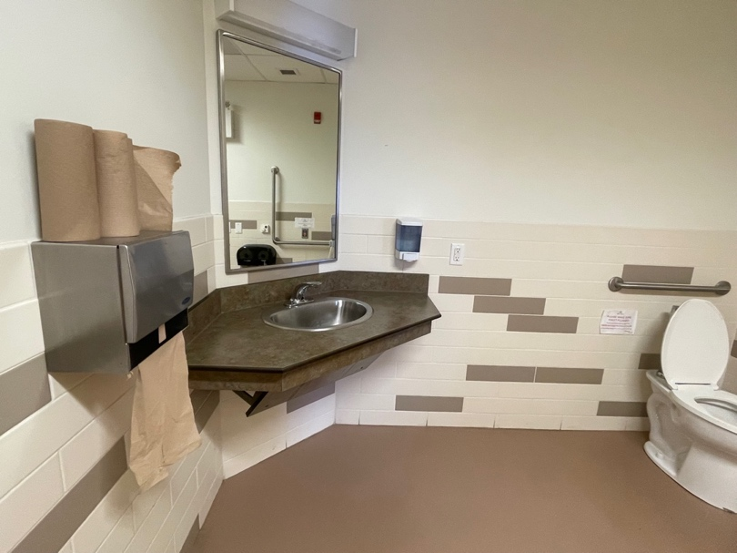
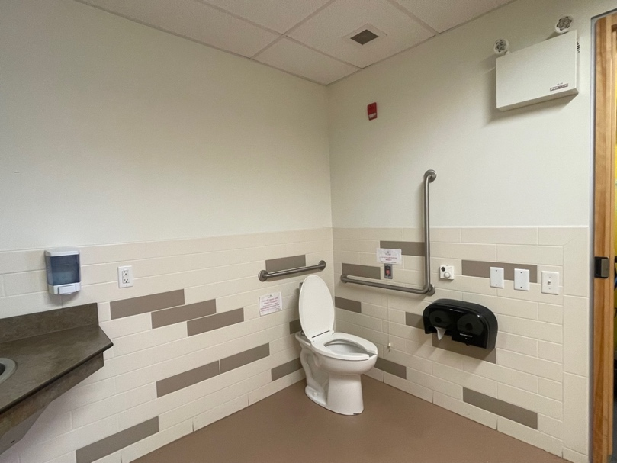

Images: 1. The door to the universal bathroom from the outside. The door opens in with a turn handle. The sign has the accessibility sign and a toilet on it. 2. The bench or changing table is across from the toilet and the sink is straight ahead after entering the door. 3. Inside the universal bathroom. The toilet is on the right. 4.The paper towel on the left wall if you are facing the sink and the manual liquid soap dispenser is on the right. The sink is automated and the mirror is low.

Women’s Washroom: Located at the end of the hallway for the washrooms. It has four stalls, three sinks, and space under the sinks. The mirror is long and starts just above the sink. The soap is a liquid manual dispenser to the left of the sinks and the manual paper towel dispenser is to the left of the soap and is higher than in the universal washroom.

The door is 93 cm or 37 inches wide.
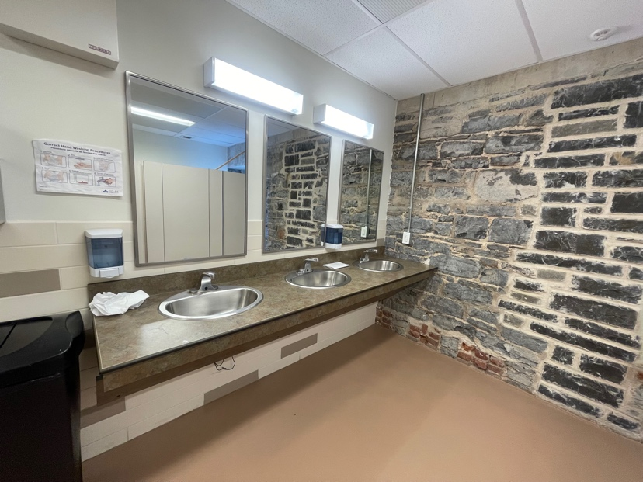
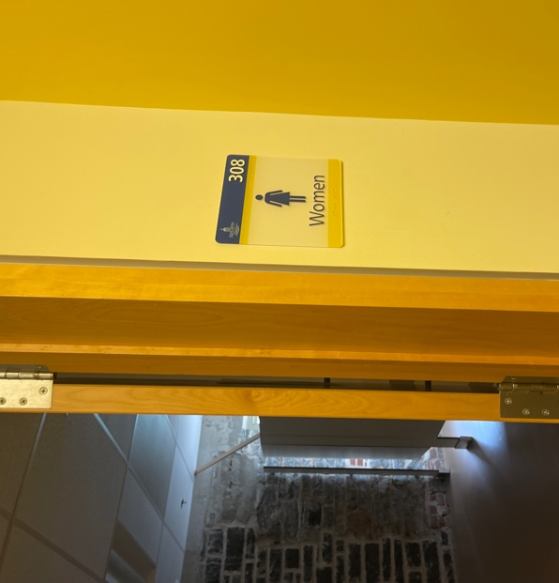

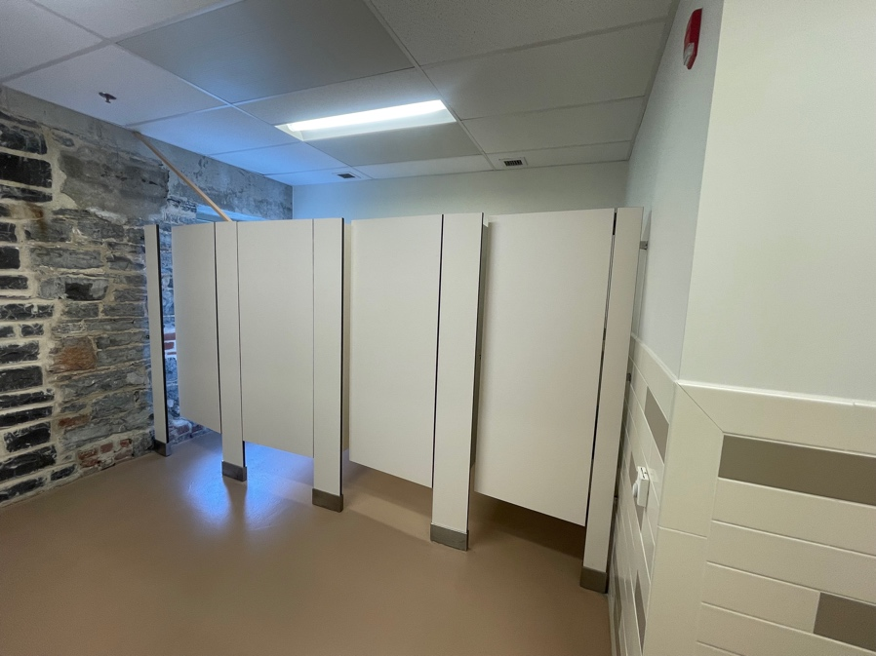
Images: 1. The entrance to the women’s washroom. The door opens in. 2. Three sinks inside the women’s washroom with space underneath, low mirrors, and a higher paper towel dispenser than the universal washroom (to the left of the mirrors on the wall). 3. The four stalls directly across from the sinks.

Men’s Washroom: Located to the left in the washroom hallway. It has two smaller stalls, and two urinals. The mirror is long and starts just above the sink. The soap is a liquid manual dispenser and is higher than in the universal washroom, as is the manual paper towel to the right of the sinks. There is space under the sinks.

The door is 93 cm or 37 inches wide.

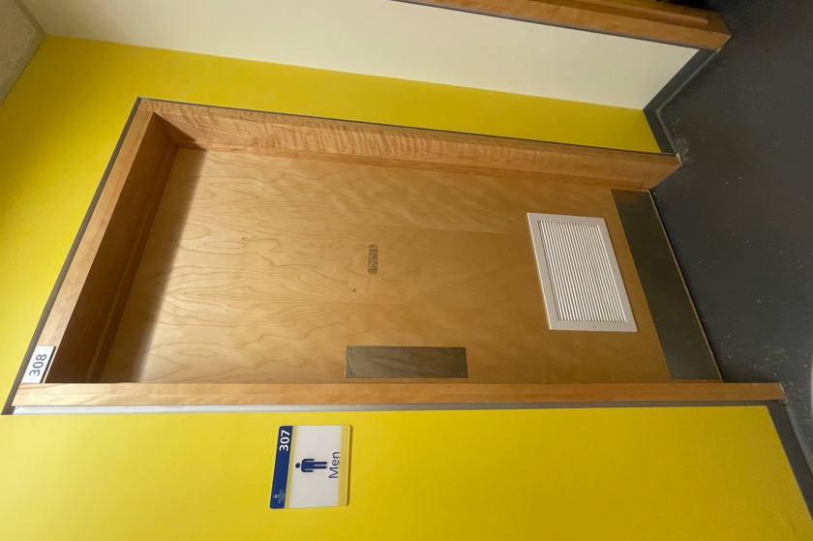
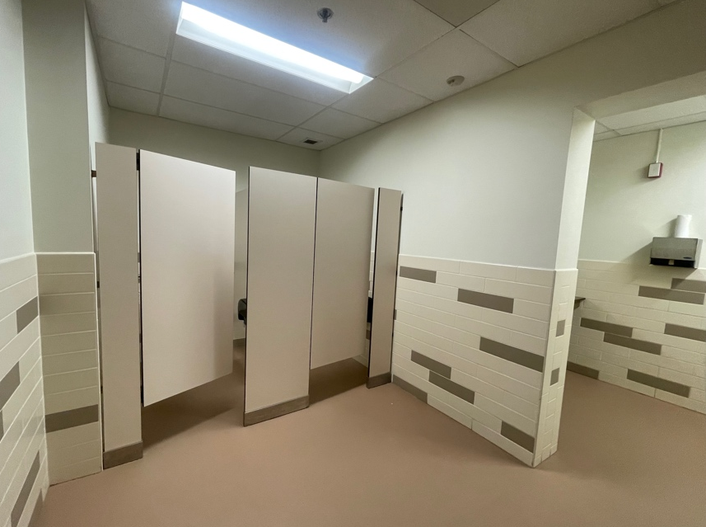

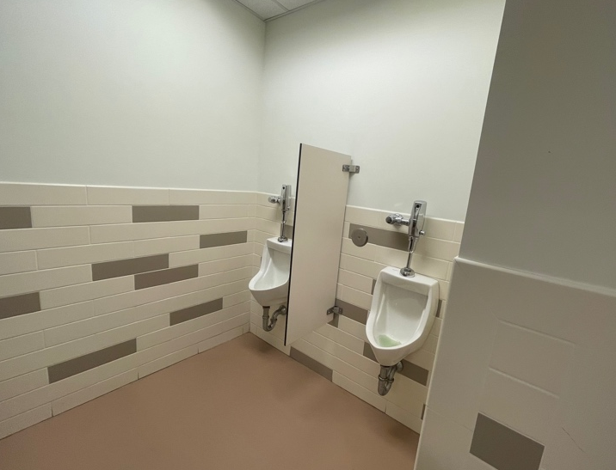
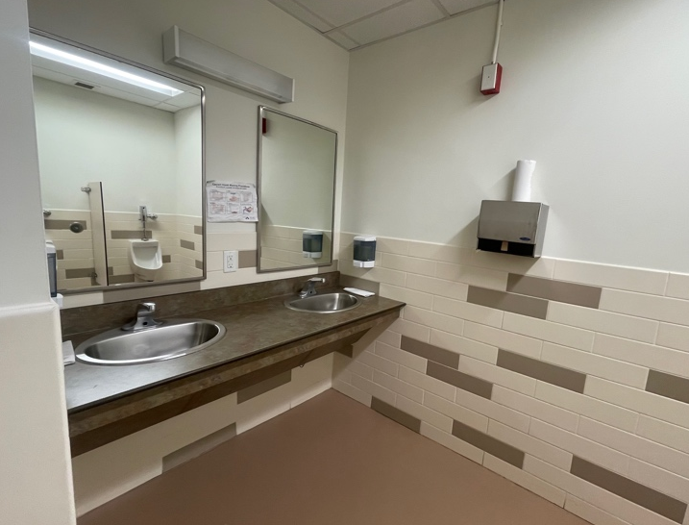

Images: 1. The door to the men’s washroom that is a push door that opens in. There is no handle. 2. Two stalls on the left after you enter the washroom. 3. Two sinks with low mirrors. The manual soap dispenser and manual paper towel dispenser are on the right wall if you are facing the sink. 4. Two urinals are on the wall opposite the stalls.

Exits and Fire Exits

There are several exits from Modern Fuel. To get outside of the building, the main exit is to the right. There is also an alternate exit on the left that leads to three flights of stairs going down. The stairwell exit (or fire exit, although it can be used as an exit anytime, just not an entrance) does not have an automatic door opener. It measures 93 cm or 37 inches wide and has a push bar across the width of the door. There are railings on either side of the stairs. The door at the bottom of the stairs opens to a small stairwell outside: three concrete steps with handrails.

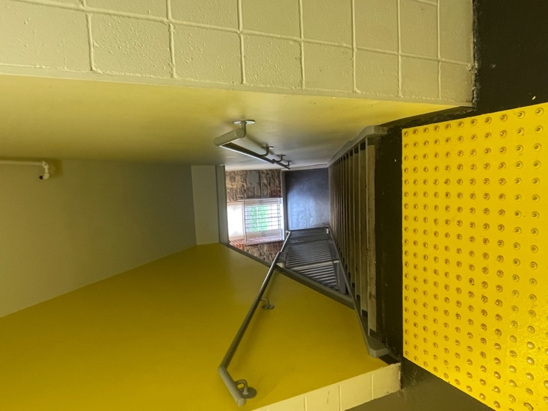
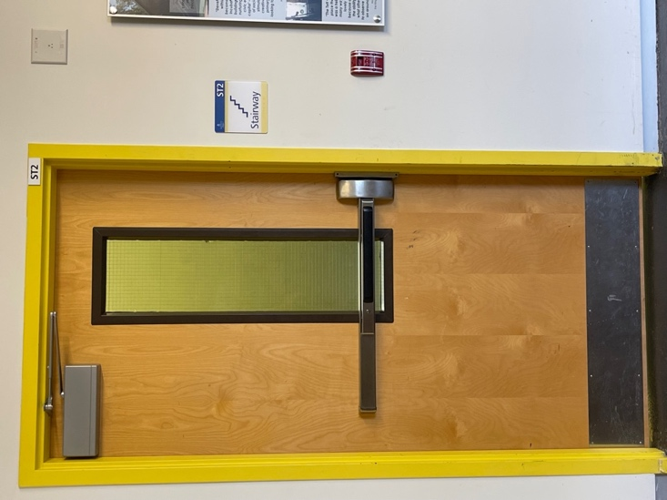

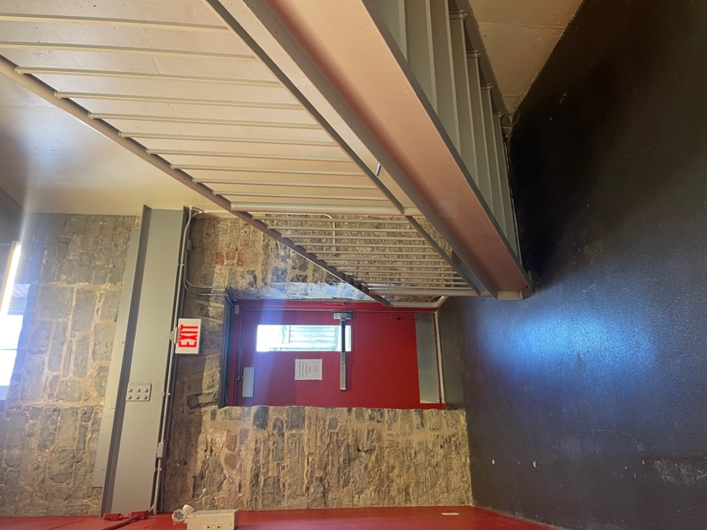

Images: 1. The door to the stairway that leads to the fire or alternate exit from the building. There is a push bar across the width of the door and it opens out from the hallway. The door opens out from the inside. 2. The top of the stairway for three flights of stairs leading to the alternate or fire exit. There are railings on either side of the stairs. 3. The fire exit or alternate exit door with the stairway on the right. The door is also a push handle and opens out.

